Music, Mac and Malabar Mansion
“The only truth is music.” ― Jack Kerouac

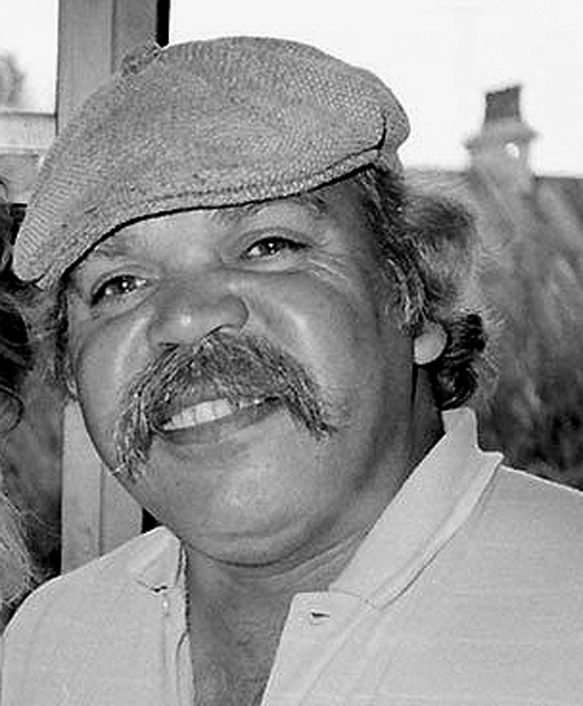
Mac Silva 1984 - Photo by Gary Foley

Music often plays a role in my thinking as I grapple with the great uncertainties of our age. At times is merely provides background static to a clever idea, and at other times it can be evocative of a bygone era and of past battles fought. Music at all times can affect the way we feel, and music has always been there in the background and sometimes forefront of our on-going struggle for justice.

One of the songs that always evoked a strong response in me is the late, great Mac Silva’s version of Malabar Mansion. It is a song that resonates to virtually all blackfellas, and it evokes feelings and thoughts on many different levels. It is the classic gaol song that is said to have been written by a white man, Dave Duncan, an inmate of Long Bay Gaol doing a short stretch for unpaid fines in the 1980s. But it is Mac Silva’s interpretation and rendition of the song that takes it and claims it for Aboriginal people in general and Aboriginal prisoners in particular.
As I was researching the origins of the song I came across an academic paper published by Macquarie University lecturer in Media Studies Dr. Peter Doyle on the very subject of the Mac Silva version of Malabar Mansion. Whilst Doyle’s paper was more interested in what the prison song meant in relation to the geographical context in which it was located, and was comparing it with another famous tune that came out of that same geographic area. The other tune was a surf club 1960s classic called Bombora by the Atlantics. Interestingly Doyle pointed out that members of the archetypal 1960s Sydney surfie culture cult guitar band, the Atlantics, were ironically mostly of Greek origin. Doyle also had some interesting things to say about Mac Silva’s version of Malabar Mansion.

Mac Silva recorded the song in 1988 for an LP called Koori Classics: prison songs. Ironically, it was in part funded by a 1988 Bicentennial grant. Doyle further noted that, “It was released on the Enrec label, then coincidentally co-run by a former member of the Atlantics Eddy Matzenik, who plays steel guitar on the song.”

Mac Silva, was the former drummer and singer with seminal Redfern bands Silva Linings and Black Lace. In 1988 he had been touring and performing in prisons with La Perouse-based Vic Simms. They were very conscious that the campaign for some sort of inquiry into the high rates of Aboriginal deaths in custody had become part of the broader agitation for social justice and land rights, and resulted in the Royal Commission into Black Deaths in Custody which was established in October 1987. That was intersecting with a wider interest in Aboriginal musicians and bands, and there was some hope that things might change for the better. So the song was released into a politically charged contemporary context.

Peter Doyle said of the recording itself, “Death is very literal and very near in Malabar Mansion”. It was that particular aspect of the song that I think gave Mac Silva’s version a particularly powerful resonance to the Aboriginal community. With so many deaths in custody occurring at the time, and the imprisonment rates of Aboriginal men at record rates, then as now, almost every Aboriginal family in Australia has at least one relative in gaol. So it is the topics that the song relates to that give it part of its power.

The twin issues of Aboriginal imprisonment rates and black deaths in custody were red hot at that moment in history. And again as Doyle observes, “Malabar Mansion departs from the prison song template a little. For one thing it’s not a cautionary tale. There’s no remorse for past sins. And the gaol here isn’t merely generic. It’s very specific. It’s Long Bay Gaol.”

“Long Bay Gaol you’re cruel and bad,
You have made sane men go mad,
Some have even took their lives at different times”

Doyle notes, “This isn’t gaol-as-metaphor-for-the-human-condition, this is real gaol ‘where the lifers think they’re king’, where the core suffering is boredom and isolation, where the greatest peril is suicide.” But to me it is clear that Mac Silva is consciously singing these lines to the audience of his own community where he knows almost everyone can relate to the experiences he is singing about.

However, the defining aspect whereby Mac Silva stamps this song as a blackfellas song is in the line he changed to refer to the “Empys” hotel as “where I drink”. Every Aboriginal person in NSW would know this is a clear and obvious reference to the legendary 1960s and 70s black pub the Empress Hotel in Redfern. Known as the “Big E”, the Empress Hotel was not just a major congregation point and meeting place of the Aboriginal community, but was also was one of the toughest pubs in Sydney in those days.

And many of the tears cried into beers in the Empress in those days were tears over absent husbands, brothers and sons who were doing time, often unjustly, in the NSW prison system. So it was again little wonder that Aboriginal people were going to strongly respond to this song. It was this mention of the Empress in Malabar Mansion that Doyle believed was “one of those references by which a song really selects its audience.”

The other equally important aspect of this song’s significance is with the singer himself. Mac Silva was one of the genuine legends of the Redfern Aboriginal community. Malcolm (Mac) Silva had been born in Kempsey in 1947. He lived on Burnt Bridge Mission until his family moved to Sydney in 1965. According to Sylvia Scott, upon arrival in Sydney Mac started performing at the Foundation for Aboriginal Affairs, managed at the time by Charlie Perkins. Mac’s band performed at the Foundation’s dances every Saturday and Sunday night, and that is where I first met him.

In 1966 he had formed the Silva Linings band with Geoffrey Compton and Steve Lugnan, That band won the Gold Coast Battle of the Sounds in 1968 and would later in 1972 change their name to Black Lace. The Silva Linings and later Black Lace were among the great institutions of the old Redfern Aboriginal community from the late 1960s through to the late 1980s. Both bands, and in particular their deadly singer Mac, were loved by the Redfern Aboriginal community because they were always there, through the good times and the bad. They were always ready to donate their time to community causes and projects, and apart from anything else, they were simply brilliant bands.

So I would assert that Mac Silva’s appropriation and interpretation of Malabar Mansion is a significant and iconic act of resistance in our long struggle for justice. And the fact that it resonates just as powerfully today as when it was recorded 25 years ago is a sad comment on the state of race relations in Australia today. The Royal Commission into Black Deaths in Custody delivered its final report on 15 April 1991 and made 339 recommendations.

The primary findings for the Royal Commission were that there were so many Aboriginal people dying in gaol partly because of the disproportionately high incarceration rates of Aboriginal peoples at the hands of the Australian criminal justice system. Therefore most of the 339 recommendations were supposedly designed to reduce incarceration rates. Despite State governments receiving generous Commonwealth subsidies at the time to assist in implementation of those recommendations, the imprisonment rates have become far worse in the 20 years since.

According to the Australian Bureau of Statistics, the rate of incarceration of Aboriginal people had risen 35 per cent between 1988 and 1995. The rate had increased 25 per cent for non-Aboriginal people. Then between 2002 and 2012, imprisonment rates for Aboriginal and Torres Strait Islander Australians increased from 1,262 to 1,914 Aboriginal and Torres Strait Islander prisoners per 100,000 adult Aboriginal and Torres Strait Islander population. In comparison, the rate for non-Indigenous prisoners increased from 123 to 129 per 100,000 adult non-Indigenous population. So clearly the situation is getting worse rather than better.

Mac Silva tragically passed away far too young at the age of 42 in April 1989 from a heart attack. His funeral was held at St Mary’s cathedral, and such was the high esteem with which he was held in his own community, the church which holds over a thousand was so full that people stood in the park across the road. He will never be forgotten by a community that clearly loved him. And his recording of Malabar Mansion remains in our consciousness to haunt us and remind us that to this day there are far more of our brother and sisters in gaol than there should be. It also reminds us that the struggle for Justice continues.

Gary Foley
October 2013

