Looking Back on 2013: A personal reflection
By Gary Foley
1st December 2013
Precious time is slipping away – Van Morrison
As this tumultuous year of 2013 comes to a rapid conclusion I would like to perhaps self-indulgently reflect on what the past twelve months have meant to me. This year has for me been dramatic in that my 63rd year was almost my last, when I suffered a completely unexpected major heart attack in July. It is only due to the remarkable skills of the magnificent medical staff in the Cardiac Unit at St. Vincent’s Hospital in Melbourne that I am still here today to write this column.
I said that my heart attack was unexpected because I thought I was in particularly good health for an Aboriginal man my age. After all, the simple reality for a Koori man like me is that the majority of Koori men my age today are dead, whilst the majority of white Australian men my age are alive and kicking. That is the brutal truth of the difference in life expectancy for Aboriginal people. But I mistakenly believed that I was going to beat the odds. I thought that because I had dramatically changed my lifestyle 23 years earlier, and because I had been riding a pushbike since I had turned 40 that I would avoid the early-death syndrome that had befallen so many of my Aboriginal brothers over the past decade or two.
But in the end it was my own self-deception that almost killed me. I was in denial about my remaining bad habit; cigarettes. Over the previous two decades I had all but ceased drinking alcohol and I had significantly improved my diet and I was riding my pushbike an average of around 30km per day. All of that plus my general belief in my own invulnerability contributed to my sense of denial about my continued smoking of cigarettes. That self-delusion came to an abrupt end when I found myself in the Intensive Cardiac Care Unit at St. Vincent’s, after being rushed to hospital and operated on whilst having a major heart attack.
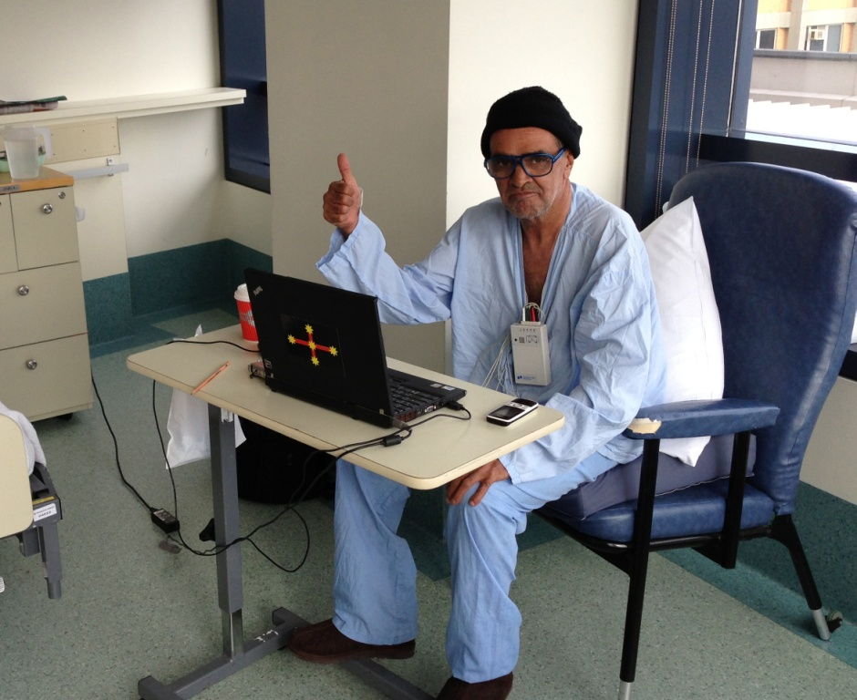
Figure 1: Writing my August Tracker column whilst in hospital after my heart attack in July
The good news however has been that I stopped smoking whilst in intensive care and have not had a cigarette since my heart attack. I am back on my pushbike and under advice of my cardiologist am riding a modest 10km a day working back up to my goal of 25-30km per day. I chose to ignore the medical advice that said I should take 3 months off work because I did not want to sit around and vegetate for that time. I suddenly had realised that I was fallible and that I still had a lot of work I wanted to complete before I die. I was back at work within two weeks of my heart attack and I feel stronger and better for the experience.
But whilst my heart attack was a dramatic new defining moment in my life, it was not in my opinion the most important event for me this year. Equally significant for me was the completion of my marathon PhD thesis at University of Melbourne. This had been a journey that had begun for me when I was expelled from Macksville High School in 1966 because, as the headmaster had informed me at the time, “We don’t want your kind here!”. This had damaged my self-confidence and self-esteem as well as having the unfortunate effect of turning me away from formal education for almost 30 years. It was not until I was insulted by a senior academic from Melbourne University in 1995 that I decided to go to university and prove something to that academic and to myself.
I completed my undergraduate degree with First Class honours in History in 2003, and then began to work part-time on a PhD. I received no scholarship so I had to work as a sessional lecturer and tutor in the Education Faculty at University of Melbourne for the first five years of work on my PhD Thesis. I was then offered a full-time teaching position at Victoria University in the western suburbs of Melbourne, where I continue to work today. My graduation ceremony at University of Melbourne in March this year for my Doctorate was attended by the Governor General. (That is not true, as she was there to receive an honorary degree herself, but I like to tell everyone she came to see me graduate, and she did get her photo taken with me).
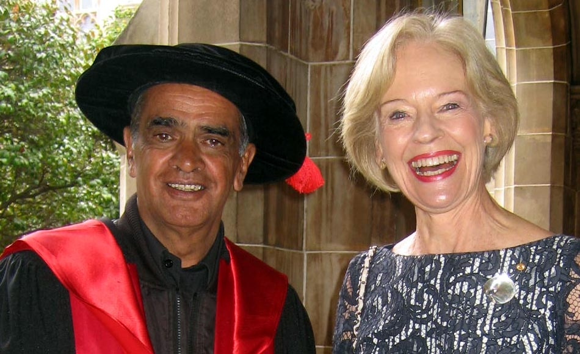
Figure 2: Cracking a joke with the Governor General at my PhD graduation at Melbourne University in March
The completion of my Doctorate was an important milestone for me because it restored the self-confidence I had taken from me in 1965, and it confirmed my belief that I could have gone on and completed university studies back then had I not had my education abruptly terminated by a racist headmaster. I remain angry that events in 1965 turned me against the idea that education was important, because that stupid notion prevented me from going to university earlier than I ultimately did, and that has probably deprived me of the opportunity to have done more teaching and writing than I have over the past 30 years.
But having said that, in terms of writing this year has been a highly productive year in terms of output. My 90,000 word PhD thesis is now being edited by me to be published early next year, and completed work on a major book edited by myself, my research associate Dr. Edwina Howell, and University of Exeter (UK) academic Dr. Andrew Schaap. That book is the most comprehensive collection of material on the 1972 Aboriginal Embassy and was launched in London in September. The book, which is titled “THE ABORIGINAL TENT EMBASSY: Sovereignty, Black Power, Land Rights and the State” was published by prestigious UK Publisher Routledge, because no Australian publishers were interested in the topic.
Also, with Dr. Howell I have almost completed work on editing the memoirs of Mr Barry Dexter titled “Pandora’s Box”. Mr Dexter was the Secretary of the Council for Aboriginal Affairs, appointed by Prime Minister Harold Holt in 1966, and later was the head of the Federal Department of Aboriginal Affairs under Prime Ministers Whitlam and Fraser. Mr. Dexter’s manuscript languished in the archives for more than twenty years until I read it two years ago and sought his permission to edit it and find him a publisher. I regard it as an extremely important work because it provides an insider’s account of some of the most significant events in Aboriginal history in the second half of the twentieth century.
Another major project I have worked on and which was completed this year is a new Documentary series to be screened on SBS-TV in early January 2014. This series was directed by Haydn Keenan and produced by his partner Gai Steele and is called “Persons of Interest”. It is a four part series about people who had ASIO files over the past 60 years, and one of the episodes is about files kept on myself and fellow Aboriginal activists from the 1950s to the 1970s. The series was recently a finalist in the prestigious 2013 Walkley Awards in the documentary section.
Among some of the other film projects I have worked on this year, probably the most enjoyable has been my involvement with my mad mate artist Richard Bell in completing his art video trilogy. The first of these videos was “Scratch an Aussie” (2008), the second “Broken English” (2009), and the latest “The Dinner Party” (2013). I regard Bell as one of the foremost contemporary artists in Australia today, and his themes that challenge Australian notions of race and white misconceptions about Aboriginal people are widely acclaimed, especially internationally. Plus he is a really funny guy who it is always a pleasure to work with.
So my message at the end of 2013 is that “I have survived” and that I am fortunate in being able to continue the work that I love, which is teaching, writing and shit-stirring. But this year there is an additional message that I convey to all my students in my classes, and especially to younger Aboriginal people. That message is the same as Hollywood actor Yul Brynner once said, “Don’t smoke”. If you do smoke then I can attest that a heart attack will ultimately be the best way you either stop or die. It is better to stop now rather than wait for that heart attack.
I wish all my readers a safe holiday break and all the best for the New Year.

Dr. Gary Foley

