Reflections on 2012 NAIDOC and the 1972 Aboriginal Embassy

This year the recent NAIDOC celebrations had as its theme, “40th Anniversary of the Aboriginal Embassy”. This created the strange phenomenon whereby that 1972 radical, anti-establishment action of the Black Power Movement was being acknowledged and honoured by the mainstream of Aboriginal Australia. The irony of this is that the vast majority of mainstream Aboriginal Australia knows virtually nothing about the 1972 Embassy action. But suddenly the search was on as local, regional and national NAIDOC functions scoured the country seeking out those still alive who may have had any connection with the 1972 protest. It seemed that every organisation in Australia intending to have a NAIDOC celebration wanted to have a genuine Aboriginal Embassy relic at their particular event. This was especially so for Government agencies which in some cases had vast amounts of money to spend on their annual token acknowledgement of Aboriginal (oh sorry, ‘Indigenous’, in the newspeak) people.

For many Government agencies and conservative Aboriginal organisations the theme of the 2012 NAIDOC proved to be mildly embarrassing. In the case of Government bodies there was the nagging concern that such a ‘political’ theme might lead to people realising upon reflection that little has changed for Aboriginal people in the 40 years since the Embassy. Such sentiments might cause thinking people to see the hypocrisy and duplicity of present Government Aboriginal policies. So the challenge for these agencies was to try and find an old Embassy activist who might not create too much embarrassment to speak at an official NAIDOC ceremony. That was always going to be a difficult task, firstly because most of the genuine 1972 Embassy activists are dead, and those who have survived mostly remain true to the radical notions of their youth.

So the demand exceeded the supply, and most Government bodies opted for standard token gestures like inviting in a few local ‘traditional owners’ to provide the now standard ‘welcome to country’, and maybe have a harmless performance of traditional dance and a short speech by some Aboriginal person who knew little or nothing about the Aboriginal Embassy. I am not saying that this happened in all instances around the country, but I bet it was the case in 90% of the token functions staged by Government bodies. Those who attended such functions must have perceived the air of insincerity and discomfort among the general white staff whose attendance was often mandatory to ensure there was a respectable number of people there to give the occasion a degree of credence.

Then there were the conservative Aboriginal organisations that are these days often controlled and administered by a class of people who are the very antithesis of the old 1972 Aboriginal activists. Again, this is not the case in all organisations, but certainly the case in many. For the new managerial elite in some of these organisations, the NAIDOC theme must have represented an affront to their neo-liberal or conservative corporate values. For some of them the concept of NAIDOC represents a quest for respectability rather than respectfulness for the shabby, long-haired radicals of the past. And for many of these too there was the problem of finding an old Embassy activist who might be trusted to make a harmless speech that did not focus on the shortcomings of today’s Aboriginal elites.

I am aware of this quest for 1972 activists because I was asked by numerous organisations and agencies from around the country to give a speech at their NAIDOC events. It was a bit of a novelty because this was the first time in 40 years that we old radicals had been so popular. However, many of these invitations evaporated when I told people what my position regarding NAIDOC was. I showed them the pamphlet that I had put out in 1972 describing NAIDOC as “Buy A Boong A Beer Week” and many invitations were instantly withdrawn. But for the rest the final death of the invitation occurred when I pointed out that if they wanted me they would have to pay my deliberately exorbitant fee. That usually resulted in the phone line suddenly going dead or the emails abruptly ceasing. But that was fine by me because I really did not want to be part of any superficial and insincere acknowledgment to forgotten ideas and dead heroes.

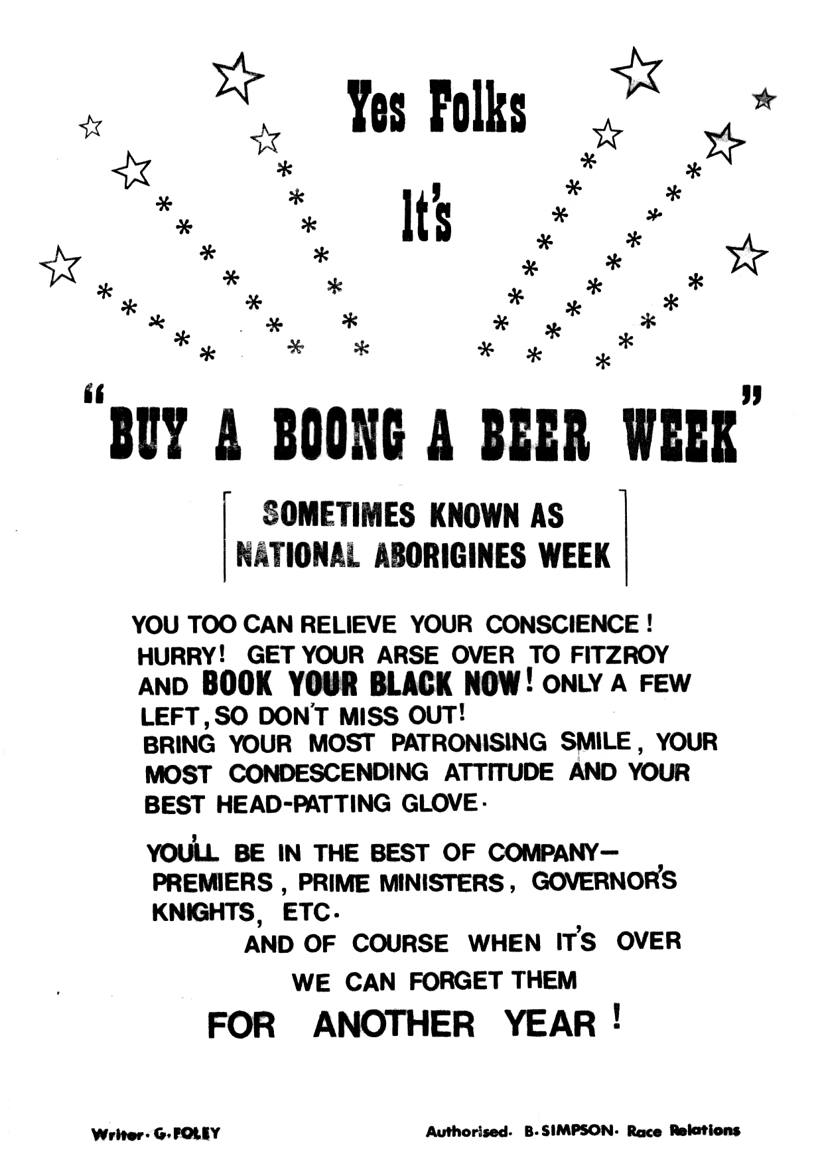
[ supplied pic of “Buy a Boong a Beer” week pamphlet to go here with caption “pamphlet written by Gary Foley for NAIDOC 1972 – Source: Foley Collection”]

It seemed to me a perverse idea to celebrate the achievements of 1972 radical black activists at a time when so many young Aboriginal people today seem indifferent and inactive in the face of present oppressive government policies. The ideas and values of the 1972 radicals empowered their generation to stand and fight against oppression and exploitation. Those of us from 1972 who are still alive today see that most of the gains we made at the Embassy have been destroyed and that the new ‘leadership’ (those Uncle Toms who are regarded by White Australia as ‘respectable and acceptable Indigenous opinion’) have spent the past decade denigrating the ideas and achievements of the 1972 Embassy and Black Power Movement, as well as vilifying the activists of that era. The recent surreptitious extension by the Gillard government of the racist and oppressive NT Intervention shows that the type of policies that the Embassy activists were vehemently opposed to are still with us, only in a more destructive form. With the political situation for Aboriginal people being worse today than in 1972 it seemed bizarre to be paying empty and meaningless tributes to a generation that stood up and fought back.

But ultimately there was one organisation in Sydney that was prepared to pay my deliberately exorbitant fee and they received the dubious benefit of an uncompromising harangue from me, whilst I used the fee to subsidise a week in the National Archives in Canberra where I did further research that when published shall remind people of just how heroic the 1972 Aboriginal Embassy Black Power activists really were. That way, I told myself, a minor compromise by me had ensured that in the near future an appropriate acknowledgement to the 1972 Embassy would emerge from NAIDOC 2012.

Gary Foley
15th July 2012

Gary Foley has over the past 40 years been an activist, actor, arts bureaucrat, museum curator, academic and writer. Today he describes himself as an ‘aging, anarchist agitator’. As well as being a historian and lecturer at Victoria University, Gary has recently staged his one-man show at the Melbourne and Sydney Festivals and completed his PhD in History at the University of Melbourne.

