A Tale of Strange Bedfellows in History
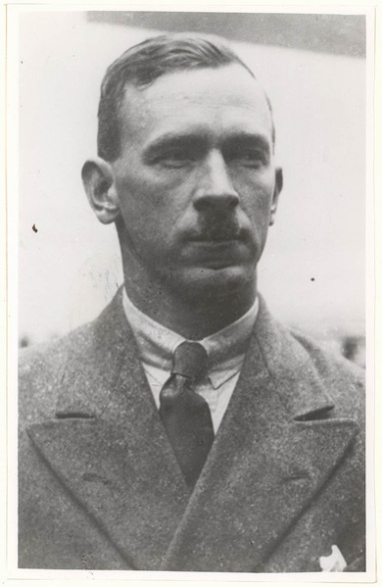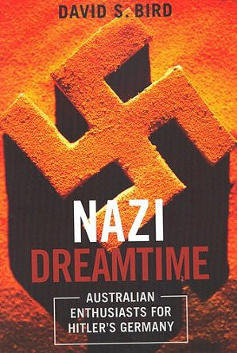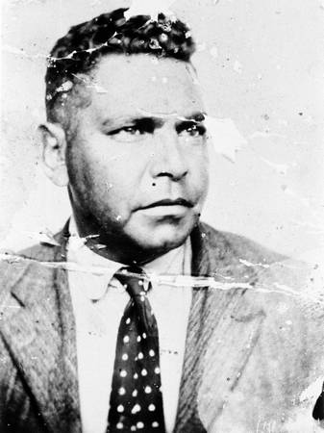
P.R. (Inky) Stephensen Jack Patten

This month I return to my favourite theme of history to talk about an extraordinary new book published in Melbourne that shines a light on a little known aspect of the Aboriginal rights movement of the 1930s. The book is called Nazi Dreamtime, written by independent Melbourne historian Dr David Bird and published in 2012 by Australian Scholarly Publishing.

The title of the book derives from the bizarre situation whereby a strange collection of Australian extremist right- wing, ultra-nationalists, some of whom were ardent admirers of Adolf Hitler and the German Nazi Party, became strong advocates and supporters of the Aboriginal rights movement of the 1930s. Furthermore, their romanticised notion of Aboriginal people derived from their belief that Aboriginal people were the original Aryan race. But first a little background.

For the Australian sympathisers of Fascism the early external model was Italian Fascism, but this did not sit well in a society with deeply embedded notions of white superiority. Thus it was by around 1936 that Australian right-wing eyes turned toward Germany. As author Bird points out in Nazi Dreamtime, “Importantly, the German variety was obsessed with concepts of ‘race’, an unavoidable factor at that time and one that had long been of primary importance to the psyche of white Australians, many of whom indulged in the ‘Aryan’ fetish of northern European difference and superiority”.

Central to this strange but true tale is a white man called P.R. (‘Inky’) Stephenson. He was one of the more colourful characters on the Australian cultural/political scene in the first half of the twentieth century. Stephenson was a writer, editor and publisher born in Maryborough QLD in 1901. Twenty years later whilst at University of QLD he edited the university magazine, Galmahra, and joined the Communist Party. Then, to the surprise of everyone who knew him, he won the 1924 Queensland Rhodes Scholarship and went off to study philosophy, politics and economics at The Queen's College, Oxford.

After graduating from Oxford University with 2nd class honours in 1927, he stayed on in England and began to publish lavishly printed and illustrated limited editions, including works illustrated by Norman Lindsay. Whilst in London he met, befriended and published novelist D.H. Lawrence and Aleister Crowley who would later be described as the “Master Satanist of the 20th Century”.

Inky Stephensen returned to Australia in 1932 and in conjunction with Norman Lindsay established a publishing company called Endeavour Press, which would publish titles including Norman Lindsay's Saturdee (1933), Banjo Paterson's The Animals Noah Forgot (1933) and Miles Franklin's Bring the Monkey (1933). Stephensen became close to Miles Franklin and also to another budding author called Xavier Herbert who was seeking a publisher for a novel he had just completed called Capricornia.

At this point in the plot enter retired businessman, W.J. (William John) Miles, who had retired in 1935 and devoted himself to secularist and chauvinist propaganda. W.J. Miles has been described as a ‘loud misogynist’, as well as ‘intolerant, pedantic, authoritative, ill-tempered, querulous, and opinionated’. He was also a strong Nazi sympathiser. As an indication of his character and personality, in 1923 after conflicts over the life-style and sexual 'freedom' of his daughter Beatrice (Bea), Miles had her committed to the Hospital for the Insane in Gladesville, where she remained until publicity in Smith's Weekly led to her release in 1925. As a result of this episode Bea Miles became homeless and mentally disturbed, and ultimately in the 1940s and 50s becoming Sydney’s most notorious eccentric homeless ‘bag lady’.

In July 1935 W.J. Miles, Impressed by Inky Stephensen, employed him as 'literary adviser' at £5 per week. It seems that it was around this time that Inky Stephensen began a swift transition from being a communist toward the extreme right of politics. From July 1936 Miles and Stephensen published a new literary magazine The Publicist, which had a strongly anti-British, anti-communist, anti-Semitic, pro-Aboriginal flavour and by 1938 was criticized for its overt Fascism. This observation probably stemmed from the fact that in May 1937 The Publicist had taken to printing the full text of speeches of Adolf Hitler at the behest of W.J. Miles. As David Bird observed, “W.J. Miles ensured...that his journal endorsed every aspect of German Nazism that came under its scrutiny in the belief that there was no conflict between national-socialism (Nazism) and ‘Australianism’”.

It was under the imprint of The Publicist that Stephensen and Miles published the first edition of Xavier Herbert’s first novel Capricornia in 1938. Miles had also published Stephensen's The Foundations of Culture in Australia (1936) and it was this book that inspired the formation of the Jindyworobak poetry movement, which was a nationalistic Australian literary movement whose white members sought to promote indigenous Australian ideas and customs, particularly in poetry.
.
Around this same time in the early 1930s in Sydney, an Aboriginal man called Jack Patten met a white political activist called Michael Sawtell. It was Sawtell who encouraged Patten to develop both his interest in politics and his oratory skills on the Sydney Domain, famous for its soapbox political orators. More importantly Sawtell would introduce Jack Patten to Inky Stephensen and W.J. Miles, who offered Patten an office in their Publicist publishing business, affording him the ability in 1938 to write and publish the first Aboriginal newspaper, The Abo Call, which was subsidised and printed by Stephensen and Miles. These two men also provided logistical and financial support for the newly formed Aborigines Progressive Association (APA), an all-Aboriginal political organisation, was set up in 1937 in New South Wales with Jack Patten as president and Bill Ferguson as secretary.

Amazingly, the two publishers of the Publicist also subsidised and help organise the 1938 Day of Mourning Aboriginal demonstration in Sydney. David Bird even suggests that Inky Stephensen actually wrote the famous Day of Mourning pamphlet distributed by the APA in the lead up to the demonstration. As if these facts aren’t extraordinary enough, the underlying rationale that dictated the actions of these right-wing, crypto-Nazi white men turns out to be even more incredible.

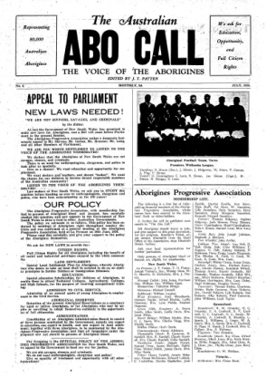
Jack Patten’s Abo Call: subsidised by WJ Miles and Inky Stephensen, printed by The Publicist

Inky Stephensen had in an earlier edition of the Publicist in 1936 declared that the treatment of Aboriginal people was the ‘most disgraceful chapter of our national story’. But earlier still in 1925 he had written a draft of a novel called The Settlers where within he put forward the theory that ‘the Aryan race began in Australia. Australia is the original home of the white man (and the white race)’. David Bird suggests that Stephensen probably picked up this idea from the ‘Black Caucasian’ theories published around the same time by an Adelaide anthropologist Dr. H. Basedow. Inky Stephensen was then able to employ this theory to justify the Publicist’s support for and financing of the Aborigines Progressive Association and their 1938 Day of Mourning protest action.

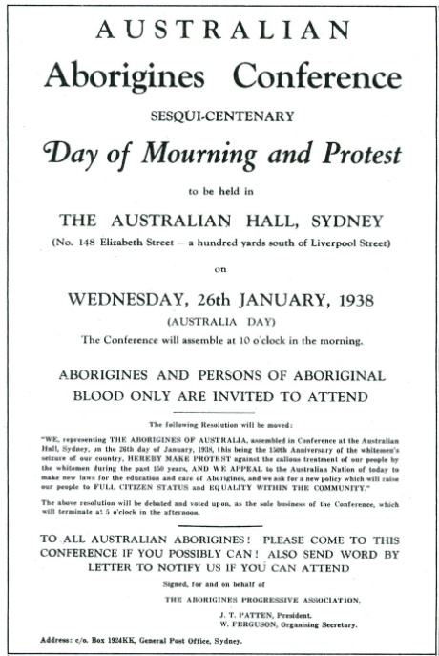
Day of Mourning pamphlet printed by The Publicist and allegedly written by P.R. Stephensen

So we end up with the extraordinary situation whereby a pair of Australian crypto-Nazis were the key financiers of the first Aboriginal political newspaper as well as the Aborigines Progressive Association and the 1938 Day of Mourning. However it must be said that this can also be seen to reflect positively on APA deputy-director and Abo Call editor Jack Patten, in the sense that it shows that he was something of a master manipulator himself in being able to manoeuvre considerable financial resources out of WJ Miles and Inky Stephensen.

A final interesting note to all of these 1930s shenanigans is that at the same time as seeking to glorify the Aboriginal resistance to racial oppression, both Miles and Stephensen and their vehemently anti-Semitic Australia First Movement which had evolved out of the Publicist were opposed to the increasing arrivals of about 15,000 German Jewish refugees in Australia by 1938. They went into an even greater anti-Semitic lather in July 1939 when news reached them that Dr. I. Sreinberg, Secretary of the Freeland League for Jewish Territorial Colonization had visited the Kimberley region in WA and declared that there were ‘millions of acres’ available for the settlement of at least 10,000 Jewish refugees. Ultimately however, nothing came of this plan. Nevertheless, the Australian anti-Semitic, closet-Nazis apparently saw no contradiction between their racial adoration of Aboriginal Australians and racial vilification of European Jews.

In the end, W.J. Miles handed the editorship of the Publicist, over to Inky Stephensen on 1st January 1942 and then died ten days later. Two months later Stephensen was arrested and held without trial in various internment camps for the rest of the war. On 28 May 1965, he collapsed and died in Sydney.
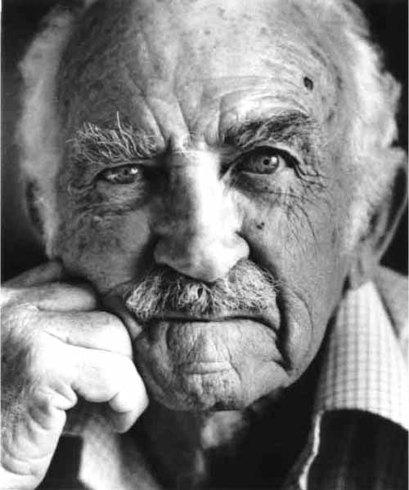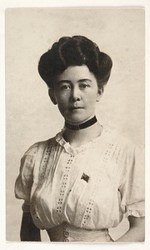
Xavier Herbert Miles Franklin

Jack Patten is remembered as one of the greatest Aboriginal activists of all time. Xavier Herbert became a legendary Australian novelist best known for his Miles Franklin Award-winning novel Poor Fellow My Country (1975). He was considered one of the elder statesmen of Australian literature. Miles Franklin is best known for her novel My Brilliant Career, published in 1901, and she has had a long-lasting impact on Australian literary life through her endowment of a major literary award known as the Miles Franklin Award. Not many people ever mention either Herbert’s or Franklin’s close associations with Australia’s crypto-Nazis of the 1930s.

Gary Foley
8th September 2013

.

