Supporting information for

Sunlight-transmitting photocatalytic membrane for reduced maintenance water treatment

Lavern T. Nyamutswa ª, Blair Hanson^{c}, Dimuth Navaratna ^{a, b}, Stephen F. Collins ^{b}, Karl G. Linden^{c} and Mikel C. Duke ^{a, *}
ª Institute for Sustainable Industries and Liveable Cities, Victoria University, 70-104 Ballarat Road, Footscray, VIC, 3011, Australia
^{b} College of Engineering and Science, Victoria University, 70-104 Ballarat Road, Footscray, VIC, 3011, Australia
^{c} Department of Civil, Environmental, and Architectural Engineering, University of Colorado Boulder, 4001 Discovery Drive, Boulder, CO 80303, USA
* Corresponding author: Mikel C. Duke (email: mikel.duke@vu.edu.au)

Number of pages: 9
Number of text sections: 10
Number of figures: 2
Number of tables: 0

Text S1. Chemicals used in the experiments
Para-chlorobenzoic acid (pCBA) was obtained from Sigma Aldrich, St. Louis, MO, USA. Methanol (HPLC grade) was purchased from Fisher Chemicals. Phosphoric acid (85% w/w) was supplied by EMD Chemicals, USA. Sodium sulphate (Na₂SO₄) was purchased from Sigma Aldrich, St. Louis, MO, USA. Sodium hydrogen phosphate (Na₂HPO₄·2H₂O) and sodium dihydrogen phosphate (NaH₂PO₄·2H₂O) were purchased from EMD Chemicals, USA. Sintered glass membranes coated with Degussa P25 TiO₂ were prepared by a previously described method ¹.

Text S2. Filtration setup
Accessories in the filtration system included a TPI 665L digital manometer (Accutherm, Melbourne, Australia) to measure the transmembrane pressure (TMP) in real time, a QG20 positive displacement pump (Fluid Monitoring Inc., Syosset, USA) to drive the feed and an electronic balance (FX-3000i WP, A&D Company Ltd., Seoul, South Korea) with associated software to measure the amount of permeate. Filtration was conducted in a previously described setup ² with manual backwashing. The modified system is presented as a schematic in Figure S1. Backwashing was carried out every hour with 15 mL of the permeate using a 40 mL syringe. The filtration mode was dead-end at a constant flux of 300 L/m²/h. Samples were collected from the backwash, permeate and feed for analysis. A 1000 W Oriel Sol 1A solar simulator equipped with a xenon arc lamp and an air mass filter to block UVC radiation provided solar radiation to the photocatalytic membrane. The spectral irradiance of the solar simulator was measured with a Maya 2000 PRO radiometer from Ocean Insight. The temperature below the solar simulator was measured using a Fisherbrand digital thermometer.

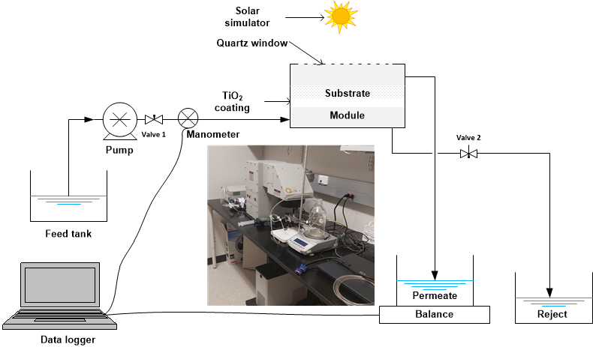
Figure S1. Schematic representation of the filtration system. The insert shows a picture of the filtration module under the solar simulator, with light travelling to the TiO₂ coating through the sintered glass substrate.

Text S3. Pump power demand

The pump instantaneous power requirement, P_{t} (kW), at a given experiment time, t (h), is given by:
$P_{t}= \frac{q_{t}p_{t}}{3.6×{10}^{6} η}$ (S1)
Where q_{t} (L/h) is the feed flow through the membrane p_{t} is the TMP (kPa), and η (-) is the pump efficiency assumed as 60%.
The specific electrical energy consumption of the pump, E (kWh/m³), is then obtained by integrating the instantaneous power over the entire experiment duration, then dividing by the total permeated volume, V_{tot} (m³), over the same time according to:
$E=\frac{1}{V_{tot}}\int_{0}^{t_{end}}{P_{t}dt}$ (S2)

Text S4. Quantification of hydroxyl radicals

A 0.6 mg/L solution of pCBA in deionised (DI) water was filtered through the membrane in dead end mode at a fixed flux of 300 L/m²/h. Permeate was collected at fixed time intervals. The concentration of pCBA in the collected permeate, as well as the feed, was determined by analysis with an Agilent Technology 1220 Infinity HPLC equipped with a C18 column and variable wavelength detector set at 234 nm. The mobile phase was made of 55% methanol and 45% 10 mM phosphoric acid, and the flow rate was set at 1 mL/minute. The injection volume was 30 µL. Using this method, which has been previously described ³, the pCBA retention time was 7.4 minutes.
The presence of photo-generated hydroxyl radicals leads to oxidation of pCBA, hence the steady state concentration of hydroxyl radicals ([HO•]_{ss} ) can be calculated from Equation S3 ⁴.
$-\frac{d\left[pCBA\right]}{dt}= k_{OHpCBA}\left[pCBA\right][{{HO}^{•}]}_{ss}$ (S3)

where k_{OHpCBA} is the pseudo first order rate constant for the degradation of pCBA with hydroxyl radicals at ambient conditions, equal to 5 × 10⁹ M⁻¹ s⁻¹ ⁵.

Text S5. Size exclusion chromatography method

In size exclusion chromatography method, the mobile phase was a 5 mM phosphate buffer of pH 6.8 made from Na₂HPO₄·2H₂O and NaH₂PO₄·2H₂O. The ionic strength of the mobile phase was adjusted with Na₂SO₄ to give a conductivity of 6 mS to supress charge interaction with the column. The ionic strength of the injected samples was also adjusted to the same conductivity value with the prepared mobile phase. The sample injection volume was 2 mL and the flow rate was 1mL/min.
Because the sample water used for this study was that of Boulder Creek (a freshwater creek/ river), humic substances are likely to contribute to the composition of NOM present in the samples. Therefore, the SEC-fluorescence detector was set to ex: 350nm, em: 450nm, to monitor the impacts of the different membrane conditions to humic substances. Because fluorescence and absorbance detectors are limited to the detection of chromophoric DOM (that which absorbs light, associated with moieties containing pi bonding orbitals, i.e., aromatic functional groups), they do not capture the entire distribution of organic carbon. Online TOC detection allows for the measurement of all organic carbon molecules, including those that are invisible to absorbance and fluorescence detectors (i.e., aliphatic moieties and compounds). Therefore, combining TOC, absorbance, and fluorescence detection results in a more complete understanding of the nature of DOM sample composition ^{6, 7}.

Text S6. Apparent molecular weight calibration method

To convert SEC elution time to apparent molecular weight (AMW), a calibration curve was generated by analysing a set of calibration standards of known molecular weights. It should be noted that because SEC separation is truly a function of hydrodynamic size (rather than the molecular weight alone), different standard compound classes yield a calibration curve specific to a given standard compound class. Therefore, conversion should be interpreted as apparent molecular weight, rather than absolute molecular weight ⁸. For this study, the AMW calibration curve was generated using Polyethylene glycol (PEG) standards of 106, 194, 410, 610, 1020, 1450, 3680, 8610, 16100, and 21160.

Text S7. Fouling indices

The hydraulic cleaning efficiency (HCE) gives a measure of the fouling that is reversed by the hydraulic backwashing process, as calculated using Equation S4 ⁹.
$HCE= \sum_{n=1}^{k}{\frac{HCE\left(n\right)}{k}}$= $\frac{P_{f}^{n}-P_{ini}^{n+1}}{P_{f}^{n}-P_{ini}^{n}}$ (S4)
where $P_{ini}^{n}$ is the initial TMP of cycle n and $P_{f}^{n}$is its corresponding final TMP.
The hydraulically irreversible fouling index (HIFI), calculated using Equation S5 when the fouling is carried out at constant flux, is a measure of fouling that is not reversed by either hydraulic backwashing or the photocatalytic processes taking place on the membrane surface ^{1, 9}.
$1/{{[P}_{0}/P_{ini}]}=1+(HIFI)V_{s}$ (S5)
where P₀ (kPa) is the TMP of the fresh membrane and V_{s} (L/m²) is volume of permeate per unit membrane area at the time the final TMP of a cycle is measured. The HIFI is then obtained from the linear plot of V_{s} against 1/(P₀/P_{ini}).

Text S8. Carbon mass balance equations
The mass of carbon (M_{F}) in a given volume of feed, (V_{F}), is given by Equation S6. V_{F} is the volume of feed that leaves the feed container (used for filtration) in a given period of time.
$M_{F}=V_{F}.C_{F}$ (S6)
where C_{F} is the concentration of carbon in the feed. The mass of carbon in the dead volume of the filtration system (M_{D}), is calculated using Equation S7.
$M_{D}={(V}_{F}-V_{P})C_{F}$ (S7)
where V_{P} is the volume of collected permeate. The mass of carbon in the collected permeate (M_{P}), is given by:
$M_{P}=V_{P}.C_{P}$ (S8)
where C_{P} is the concentration of carbon in the permeate. A portion of permeate, (with volume V_{BS}), was used for backwashing the membrane, and the mass of carbon in this backwash solution coming from the permeate (M_{BS}), was calculated by:
$M_{BS}=V_{BS}.C_{P}$ (S9)
Assuming that all the carbon in the permeate portion used for backwashing (of volume V_{BS}) all goes to the collected backwash fraction after backwashing, and all carbon removed from the membrane surface is redissolved and measured in solution, the mass of carbon in the collected backwash fraction (M_{BF}) is given by:
$M_{BF}=V_{BS}.C_{BF}$ (S10)
where C_{BF} is concentration of re-dissolved carbon in the collected backwash fraction. C_{BF} can be measured directly from the collected backwash fraction and can be used to calculate the amount of carbon coming from permeate (volume V_{BS}) plus that washing off the membrane from previously retained carbon (of mass M_{BF}). In this case the volume of permeate used for backwashing (V_{BS}) is equal to the volume of collected backwash fraction (V_{BF}).
Assuming that all the carbon from the feed arriving at the module is sent to the membrane, the total mass of carbon retained on the membrane (M_{RT}), is given by
$M_{RT}=M_{F}-M_{D}-M_{P}$ (S11)
The carbon is retained either as reversible fouling which is washed off the membrane and collected in the backwash fraction, or as irreversible fouling which remains on the membrane surface or in the pores after backwashing. However, due to the analysis method, only the re-dissolved portion of reversible fouling carbon is measured. Some reversible carbon fouling could have ended up as suspended particles, which were removed by a 0.45 um filter just before TOC analysis. The mass of redissolved carbon retained on the membrane as reversible fouling (M_{RR}) is given by:
$M_{RR}=M_{BF}-M_{BS}$ (S12)
The mass of carbon retained on the membrane as irreversible fouling, as well as that which did not go back into solution, referred to as lost carbon (M_{IL}) can then be determined by:
$M_{IL}=M_{RT}-M_{RR}$ (S13)
The contribution to total retained carbon (M_{RT}) of the redissolved reversible carbon (M_{RR}) and lost carbon (M_{IL}) can be presented as a normalised proportion of M_{RT} in units of mg C/mg C_{F}, standing for mg of carbon per mg of carbon fed to the membrane.
${Contribution to M_{RT}=(M/M}_{RT})/(M_{F}-M_{D})$ (S14)
where M is either M_{RT} or M_{IL}.
For an amount of carbon arriving at the membrane surface, the percentage removal is given by
${\% C Rejection= M}_{RT}/(M_{F}-M_{D})$ (S15)

Text S9. Contact time
The contact time, t_{c} (s) of DOM with the photocatalytic TiO₂ layer of thickness 15 µm ¹ was calculated using Equation S16 ¹⁰:

$t_{c}= 3.6\frac{δ φ}{J}$ (S16)

where δ is the thickness of the membrane (µm) and φ represent is the porosity (0.44 ²), and J is the membrane flux (L/m²/h).

Text S10. Rejection % based on HPSEC

For each detection method, the total signal for each particular sample was obtained by integrating each curve. The obtained areas where then used to calculate the membrane rejection by:
$Rejection \%=1- \frac{A_{perm}}{A_{feed}} × 100$ (S17)
where A_{perm} and A_{feed} are the areas for the permeate and feed signals, respectively.

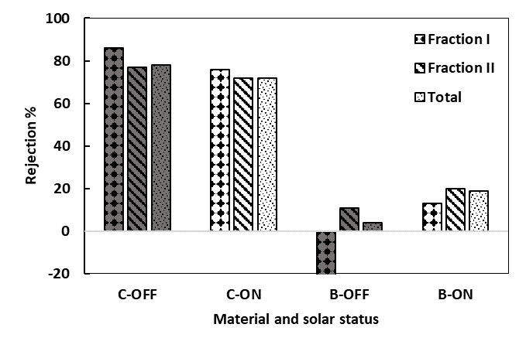  (a) | 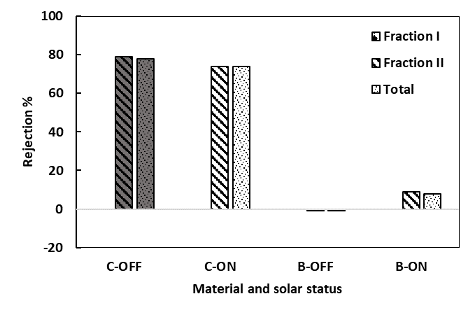  (b)
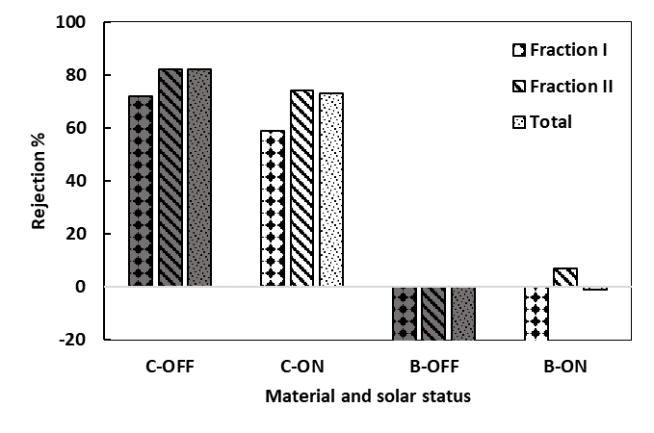
(c)
Figure S2. The rejection of AMW fractions and total rejection based on TOC (a), fluorescence (b) and UV254 (c)

References
1. Nyamutswa, L. T.; Zhu, B.; Collins, S. F.; Navaratna, D.; Duke, M. C., Light conducting photocatalytic membrane for chemical-free fouling control in water treatment. Journal of Membrane Science 2020, 604, 118018.
2. Nyamutswa, L.; Zhu, B.; Navaratna, D.; Collins, S.; Duke, M., Proof of Concept for Light Conducting Membrane Substrate for UV-Activated Photocatalysis as an Alternative to Chemical Cleaning. Membranes 2018, 8 (4), 122.
3. Kover, S. C.; Rosario-Ortiz, F. L.; Linden, K. G., Photochemical fate of solvent constituents of Corexit oil dispersants. Water Research 2014, 52, 101-111.
4. Mamane, H.; Shemer, H.; Linden, K. G., Inactivation of E. coli, B. subtilis spores, and MS2, T4, and T7 phage using UV/H2O2 advanced oxidation. Journal of Hazardous Materials 2007, 146 (3), 479-486.
5. Bounty, S.; Rodriguez, R. A.; Linden, K. G., Inactivation of adenovirus using low-dose UV/H2O2 advanced oxidation. Water Research 2012, 46 (19), 6273-6278.
6. Cai, M.-H.; Wu, Y.-P.; Ji, W.-X.; Han, Y.-Z.; Li, Y.; Wu, J.-C.; Shuang, C.-D.; Korshin, G. V.; Li, A.-M.; Li, W.-T., Characterizing property and treatability of dissolved effluent organic matter using size exclusion chromatography with an array of absorbance, fluorescence, organic nitrogen and organic carbon detectors. Chemosphere 2020, 243, 125321.
7. Sim, L. N.; Chong, T. H.; Taheri, A. H.; Sim, S. T. V.; Lai, L.; Krantz, W. B.; Fane, A. G., A review of fouling indices and monitoring techniques for reverse osmosis. Desalination 2018, 434, 169-188.
8. Wünsch, U. J.; Stedmon, C. A.; Tranvik, L. J.; Guillemette, F., Unraveling the size-dependent optical properties of dissolved organic matter. Limnology and Oceanography 2018, 63 (2), 588-601.
9. Chang, H.; Liang, H.; Qu, F.; Shao, S.; Yu, H.; Liu, B.; Gao, W.; Li, G., Role of backwash water composition in alleviating ultrafiltration membrane fouling by sodium alginate and the effectiveness of salt backwashing. Journal of Membrane Science 2016, 499, 429-441.
10. Zhu, Y.; Wei, J.; Zhang, H.; Liu, K.; Kong, Z.; Dong, Y.; Jin, G.; Tian, J.; Qin, Z., Fabrication of composite membrane with adsorption property and its application to the removal of endocrine disrupting compounds during filtration process. Chemical Engineering Journal 2018, 352, 53-63.

